1. **Create one jenkins job using the below code and create three stages.**

1: Git clone to download the source code.

2: Sonarqube Integration to check the quality of code stage

3: Slack Integration to send the alerts to slack.

URL: [https://github.com/betawins/VProfile-1.git](https://github.com/betawins/VProfile-1.git" \t "https://app.slack.com/client/T03TRQ064Q0/_blank)

1. Need to create 2 instance and download Java and Jenkins
2. Create one job in jenkins as Vprofile and put the above URL in jenkins
3. Go to gitbash use commands -->cd /var/lib/jenkins/workspace/Vprofile/-->ls

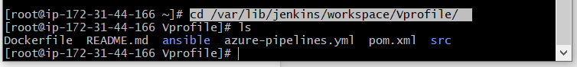

1. Than need to create SonarQube instance and install install Java in that server

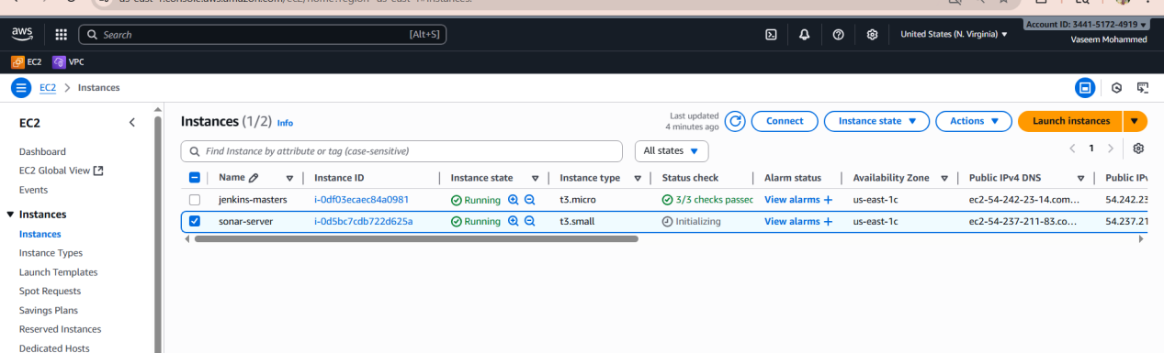

1. Now need to install java in sonarqube server -->yum install -y java -->Java --version

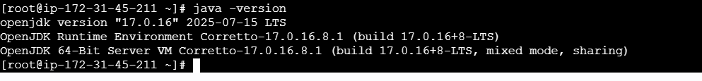

1. Now we need to install mysql in sonarqube server

sudo rpm --import <https://repo.mysql.com/RPM-GPG-KEY-mysql-2023>

sudo systemctl start mysqld

sudo systemctl enable mysqld

sudo systemctl status mysqld

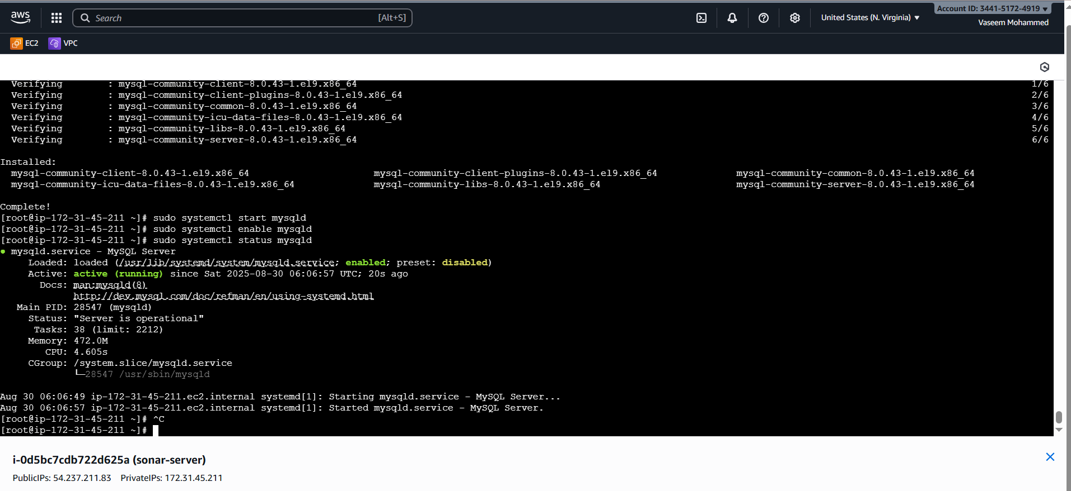

1. Than need to login to mysql using the command -->sudo grep 'temporary password' /var/log/mysqld.log
2. After login now need to change the password by using command--> ALTER USER 'root'@'localhost' IDENTIFIED BY 'NewPassword@123';
3. Flush privileges;

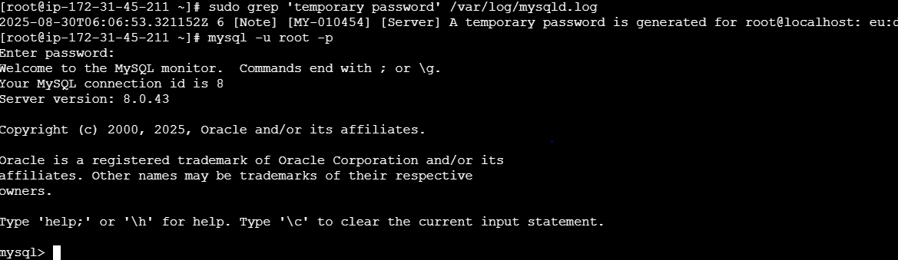

1. Do exit and again login with new password check the created password works or not

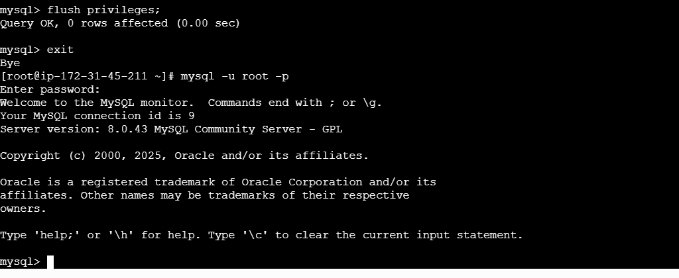

1. Now we need to install sonarqube on sonarqube gitbash by using commands
2. First we should be in -->cd /opt always
3. Download with package-->wget https://binaries.sonarsource.com/Distribution/sonarqube/sonarqube-6.0.zip
4. Than unzip the snarqube by using command-->unzip sonarqube-6.0.zip
5. Rename the sonarqube -->mv /opt/sonarqube-6.0 /opt/sonar

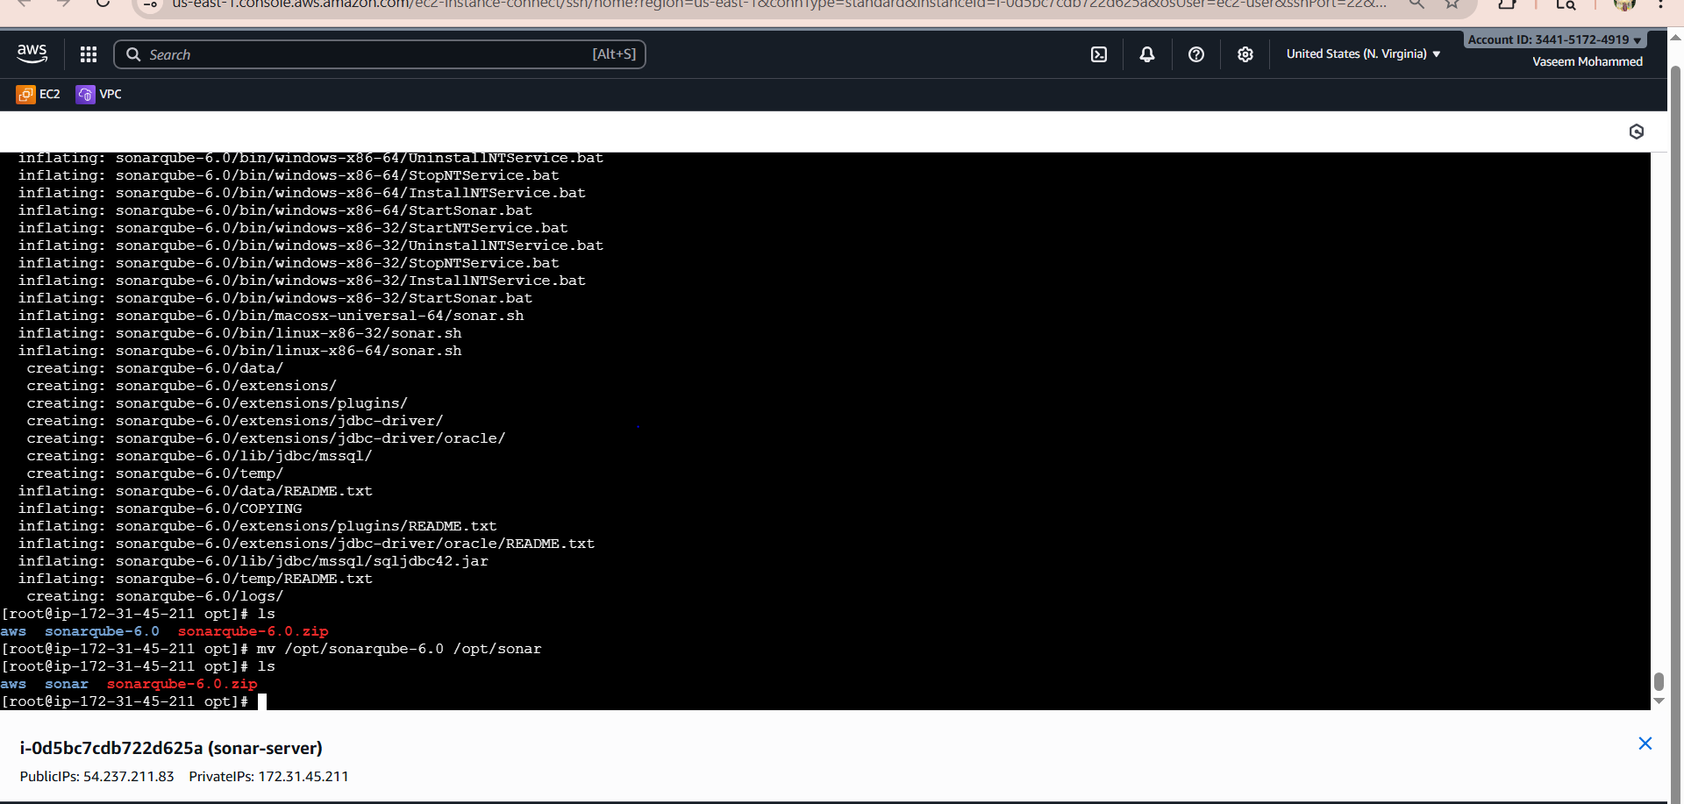

1. Now again login to mysql

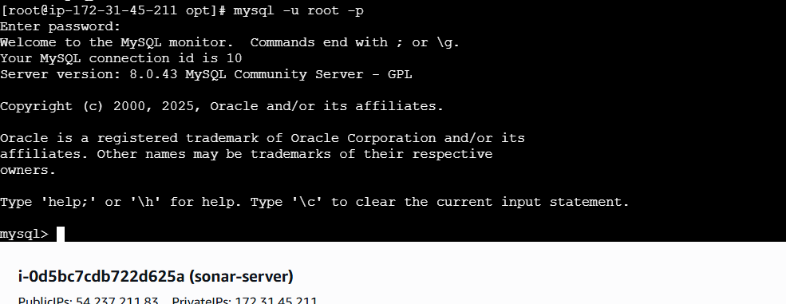

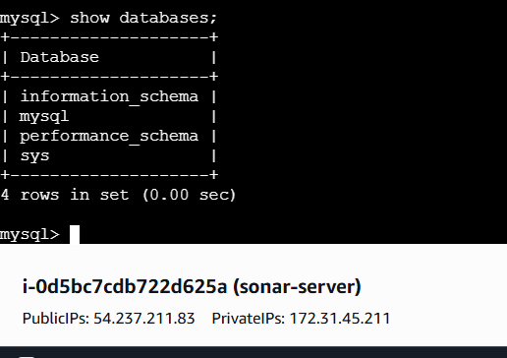

1. Now need to create one DB with name sonar in mysql by using command --> CREATE DATABASE sonar CHARACTER SET utf8 COLLATE utf8_general_ci;

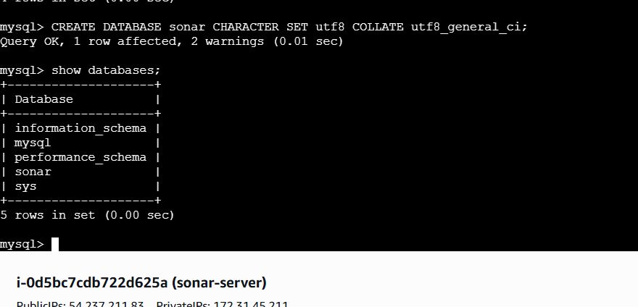

1. Now need to create 2 user with localhost and remote and grant premissons to users by using commands

CREATE USER sonar@localhost IDENTIFIED BY Sonar@123

GRANT ALL ON sonar.* TO sonar@localhost;

CREATE USER sonar@'%' IDENTIFIED BY 'Sonar@123';

GRANT ALL ON sonar.* TO sonar@’%’;

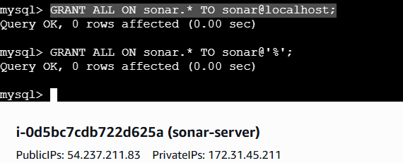

1. To check the created user use command --> SELECT user, host FROM mysql.user; and do EXIT from database

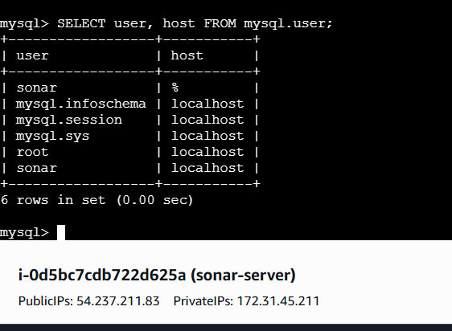

1. Now go to gitbash and use command -->ls-->cd sonar/-->ls-->cd conf/-->ls

And we can see he sonar.properties file, need to make some changes in the file like remove # before username & passwrods and add name & passowrd from that lines and SAVE

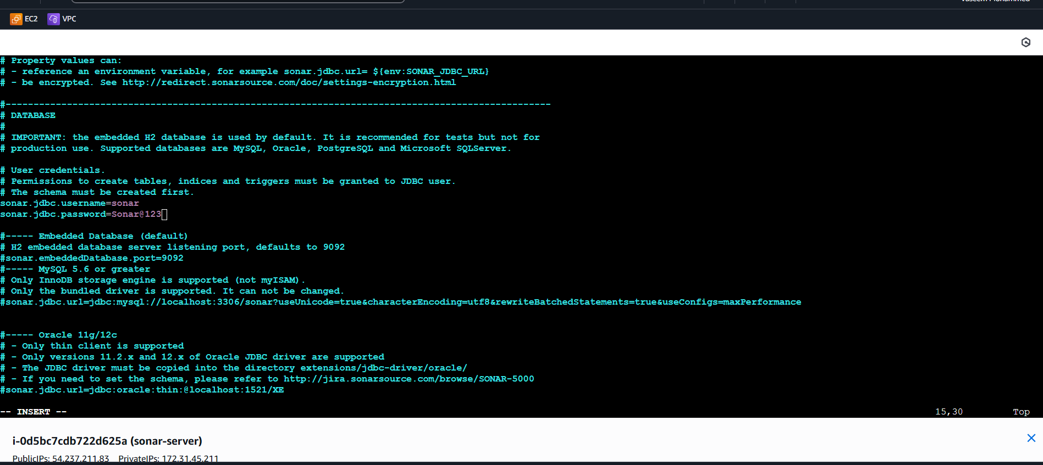

1. Than we need to exit from root and in ec2-user use commands --> cd/opt/sonar/bin/ --> ls--> cd linux-x86-64-->ls-->./sonar.sh start After executing this will get started and failed to start sonarqube. So in this case need to troubleshoot by using commands by checking in logs and everything if then also not get started and failed, use commands

Cd /opt/-->ll we see that the sonaris in root

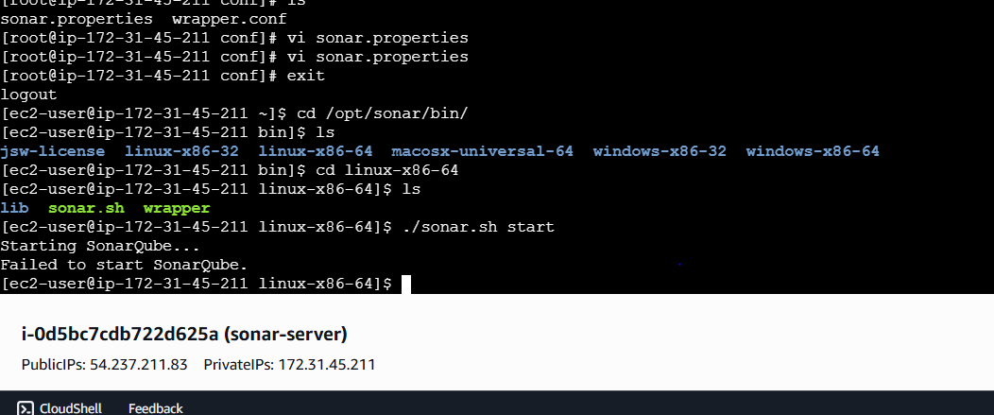

1. So in this case need to troubleshoot by using commands by checking in logs and everything if then also not get started and failed, use commands cd /opt/-->ll we see that the sonaris in root and need to change the ownerhip of that by using command -->sudo chown -R ec2-user:ec2-user sonar -->ll

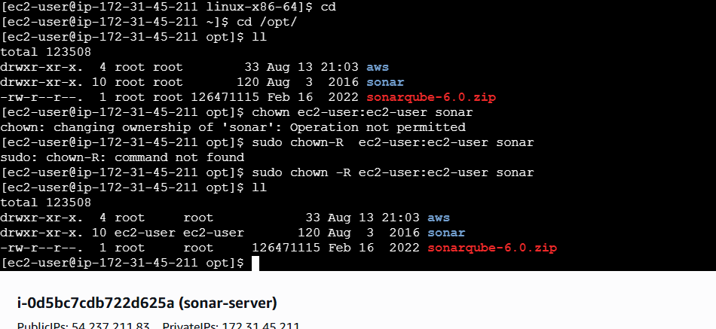

1. After changing the ownership again go to -->cd/bin/linux-x86-64, we see that sonarqube will get started

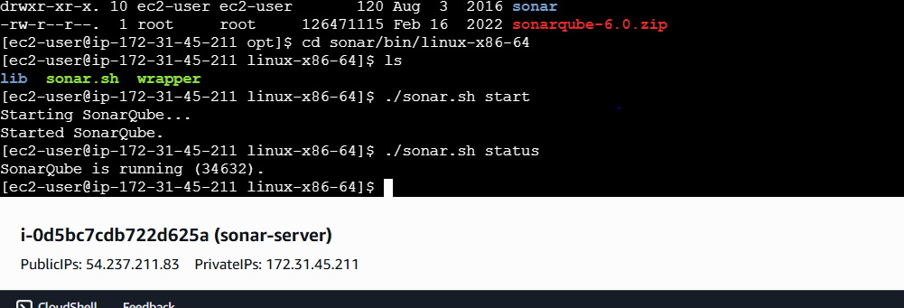

1. Here I did everthing and executed everything and make that sonarqube started also, but still sonarqube page is not getting open, so I did from instaling the docker in root user in sonarqube gitbash by using command ----> yum -y install docker-->systemctl start docker-->systemctl start docker-->docker pull sonarqube-->docker images and below is the picture

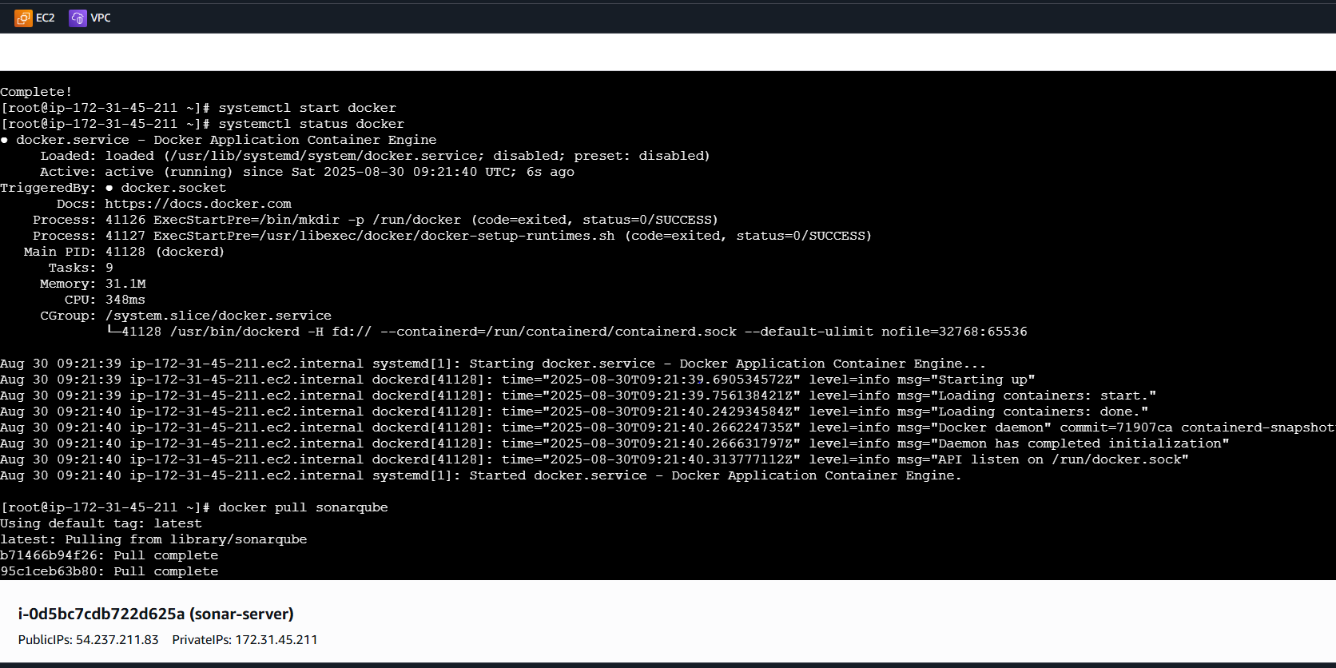

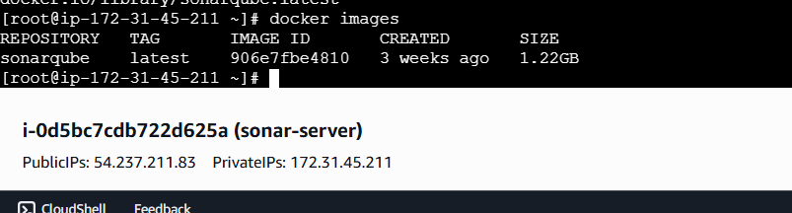

1. Than using command --> docker run -itd -p 9002:9000 sonarqube-->docker ps

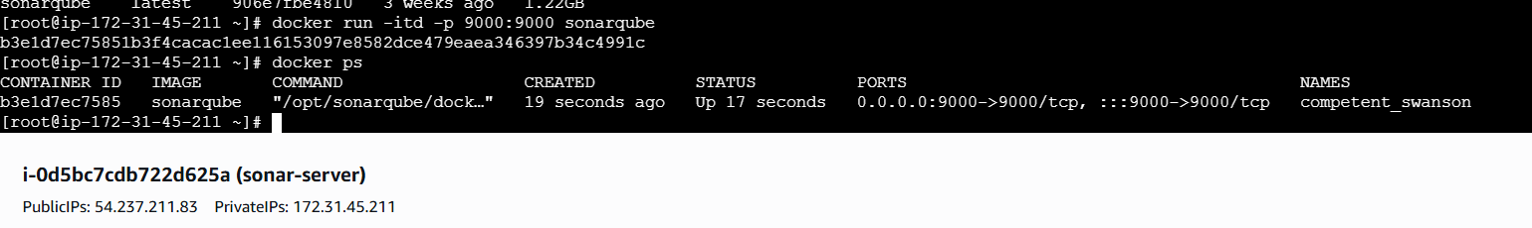

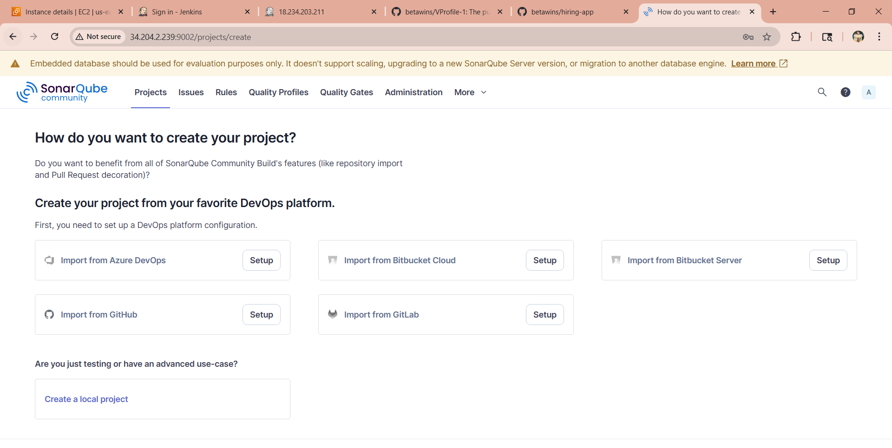

Install SonarQube Scannercin jenkins-->manage jenkins-->plugins-->sonarqube scanner

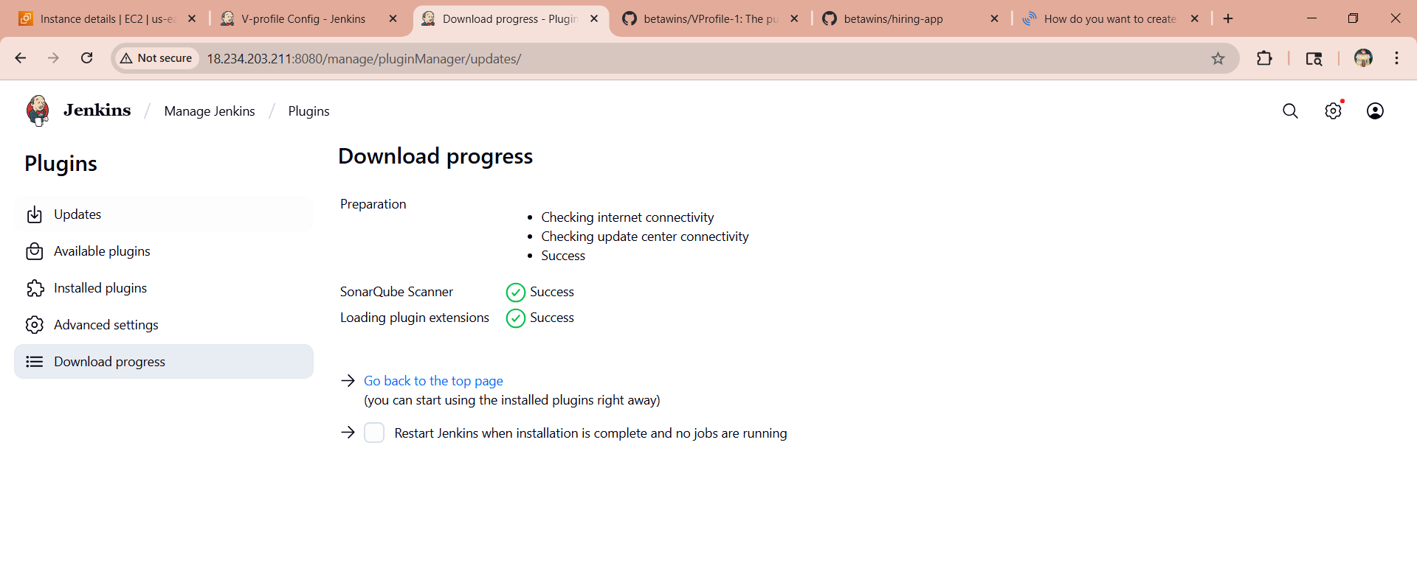

Then refresh the jenkins page and will get the sonarqube our V-profile job

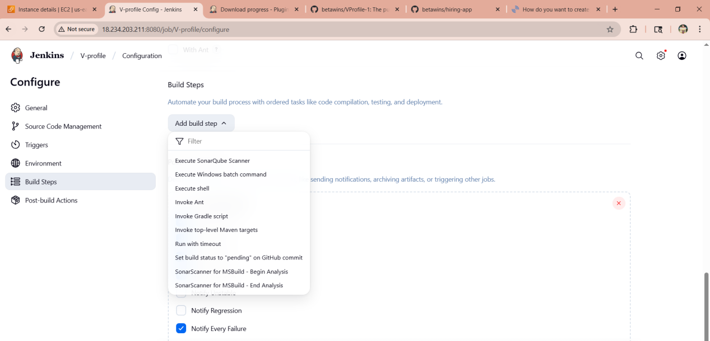

Than go to manage jenkins-->system (scroll down)-->sonarqube server

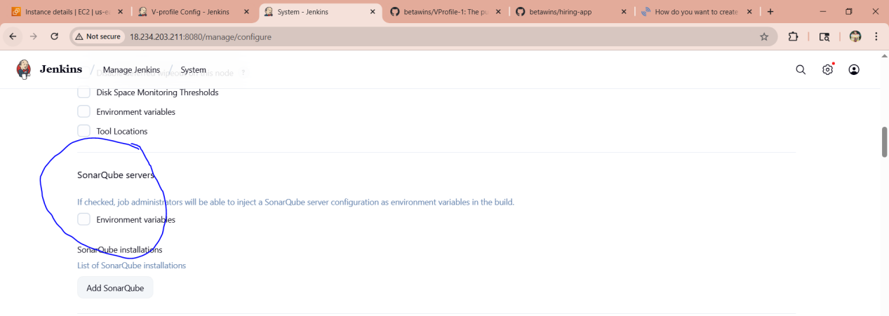

Go to --> gitbash use below commands for sonarqube scanner and enter the location in sonarqube

# wget https://binaries.sonarsource.com/Distribution/sonarqube/sonarqube-6.6.zip

# unzip sonarqube-6.6.zip

# mv /opt/sonarqube-6.6 /opt/sonar

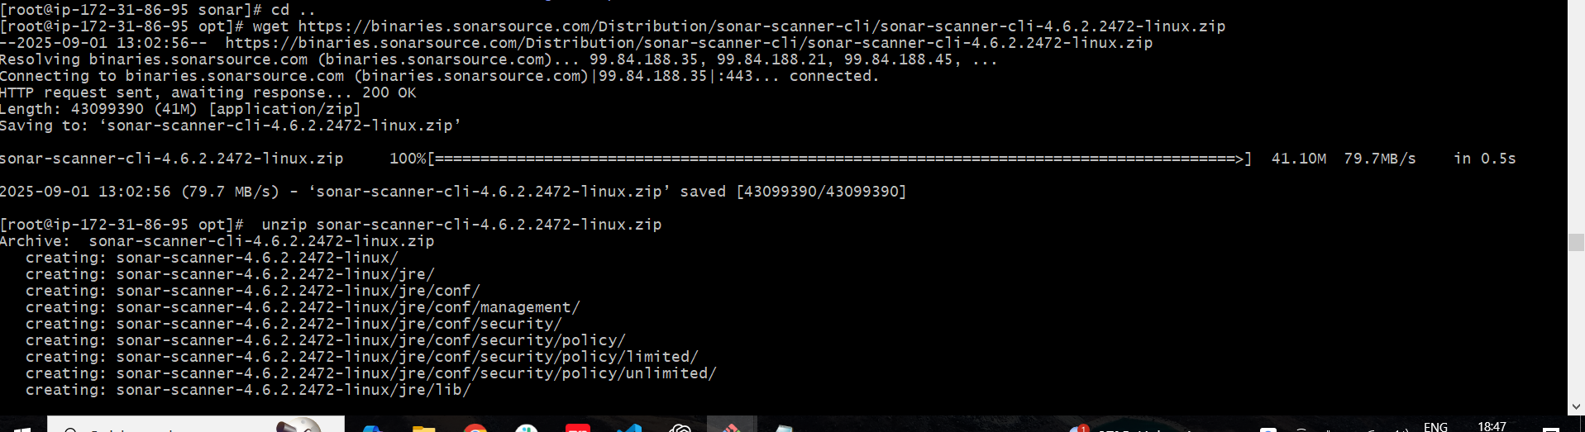

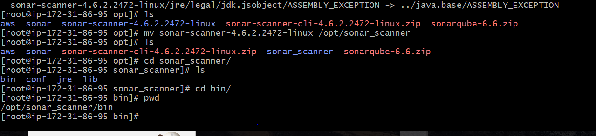

Go to manage jenkins --> tools

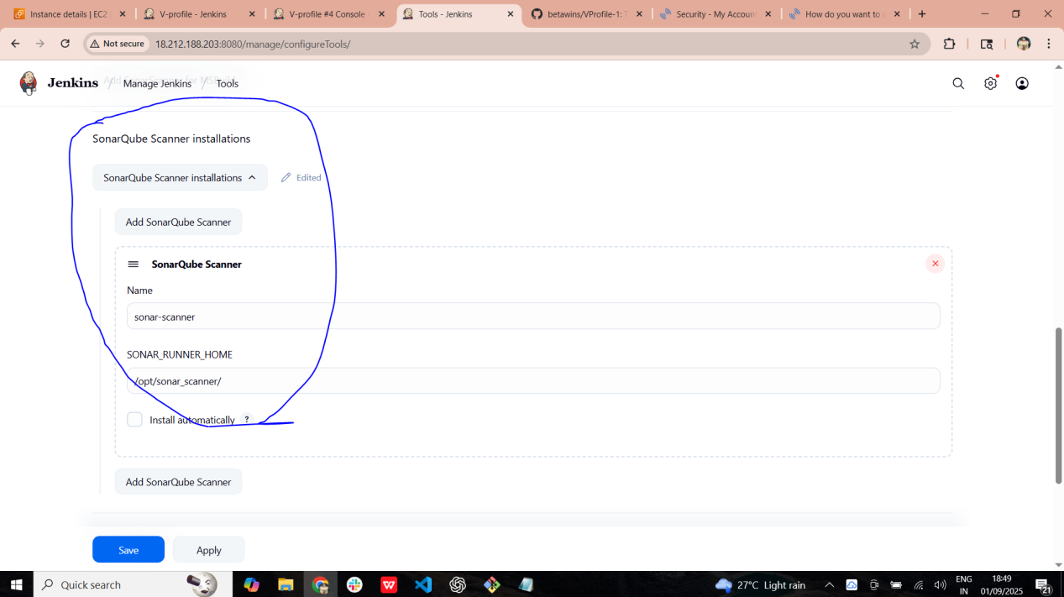

Than need to go our created job--> configuration --> scroll down --> in build steps enter the below properties and click build now

sonar.projectKey=Vaseem

sonar.projectName=Vaseem

sonar.projectVersion=1.0

sonar.sources=/var/lib/jenkins/workspace/$JOB_NAME/src/

sonar.binaries=target/classes/com/visualpathit/account/controller/

sonar.junit.reportsPath=target/surefire-reports

sonar.jacoco.reportPath=target/jacoco.exec

sonar.java.binaries=src/main/java/com/visualpathit/account/

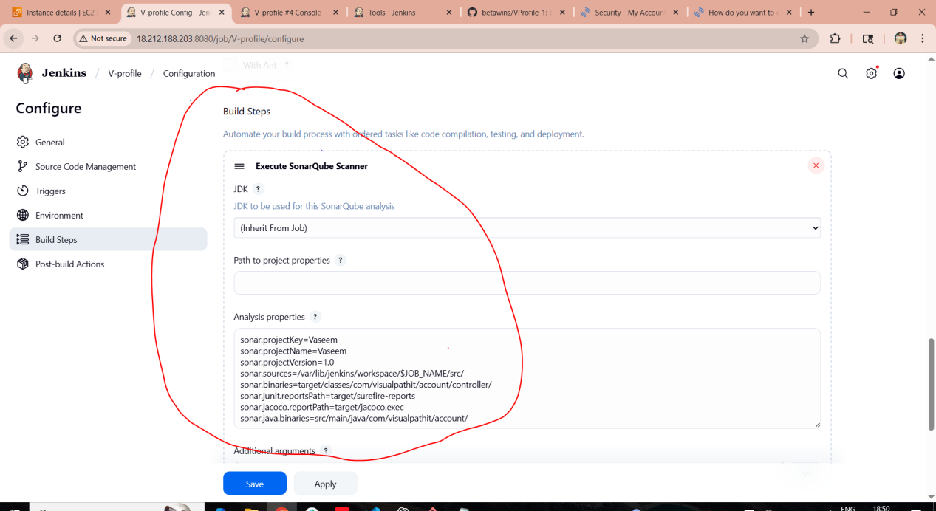

Than now build the job and will get success

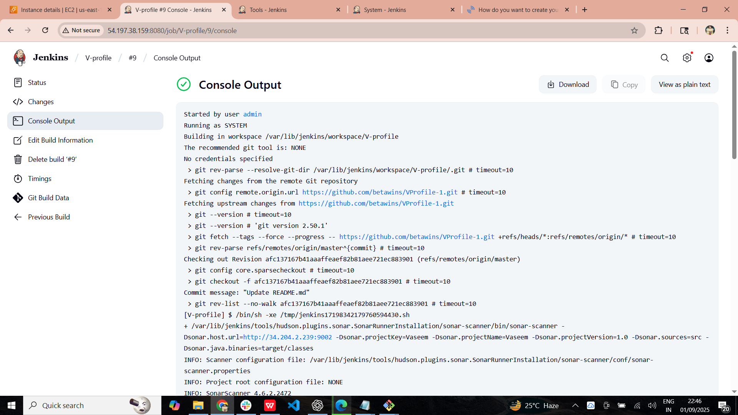

Go to sonarqube refresh the page or run again it will apper this

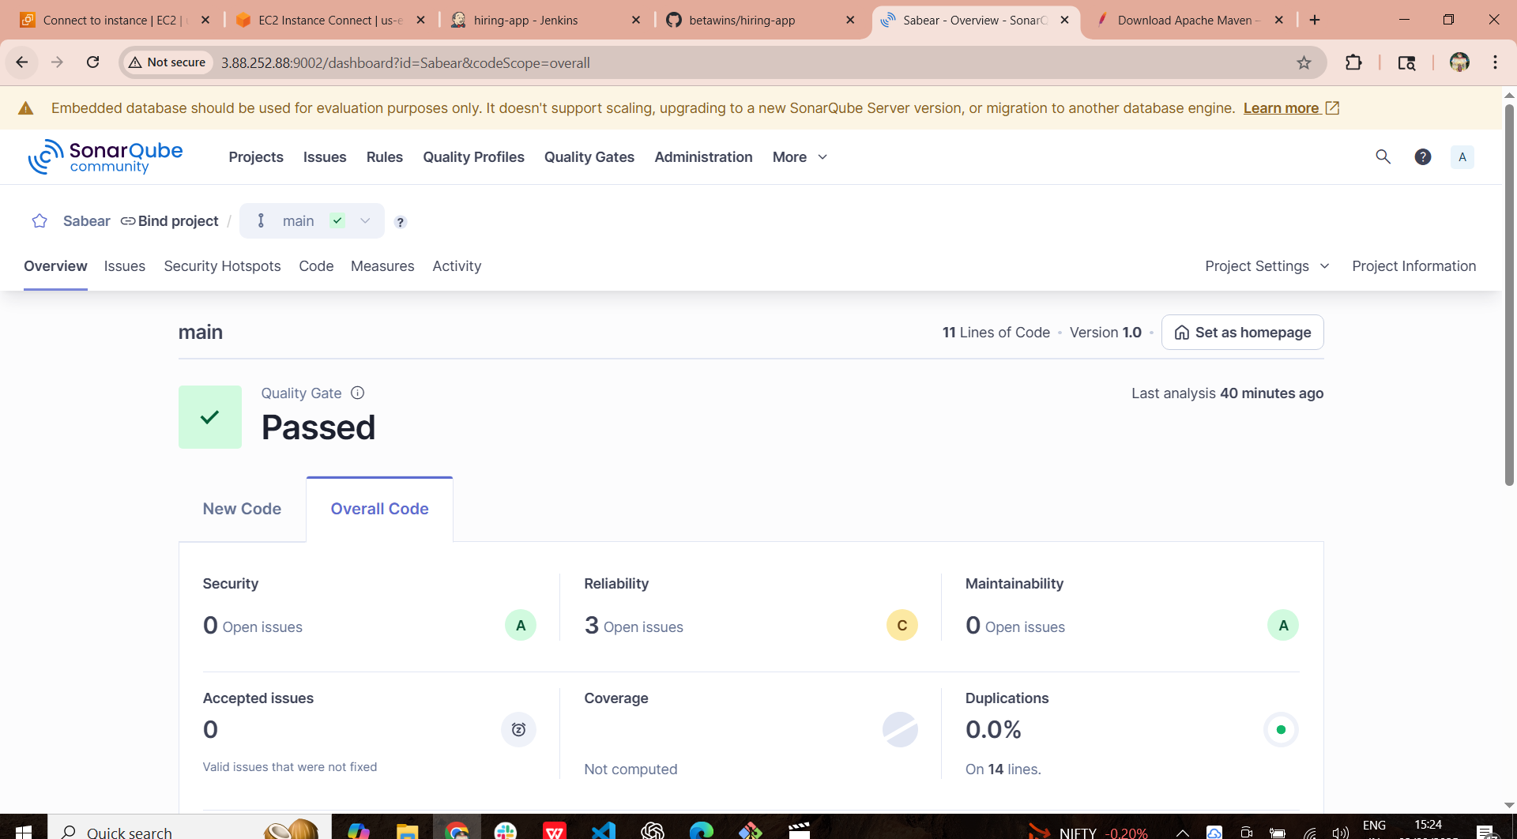

**Slack Notification**

1. Go to jenkins>manage jenkins>Plugins>available plugins>search as (slack notifiactions) and install

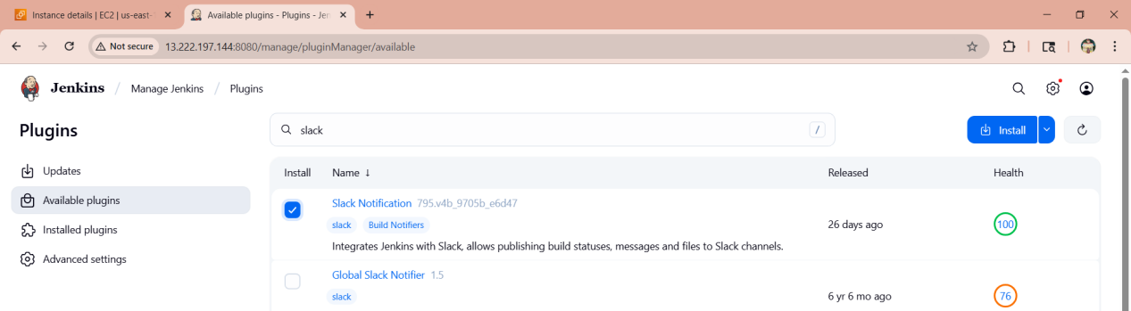

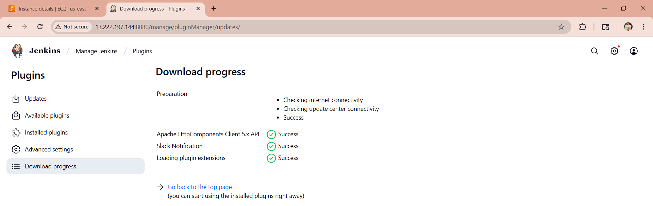



Now go to slack on browser>jekins CI >click on add to slack>new configuration>give name as (#jenkins-integration)>hit add jenkins CI integration

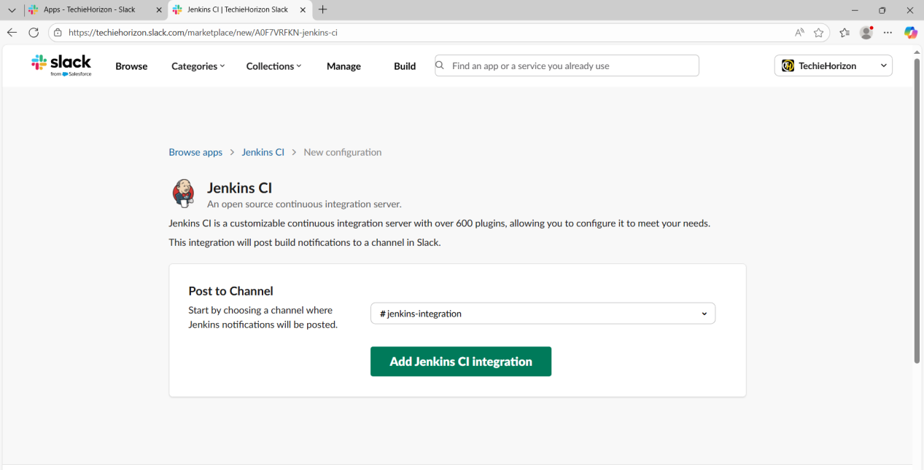

Now go to jenkins>manage jenkins>system>scroll down to last>slack put the details and in credentials enter token from slack page>hit SAVE

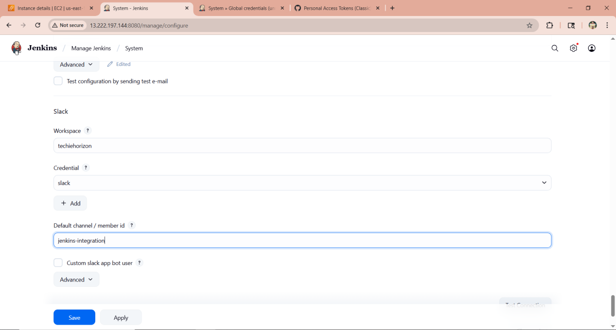

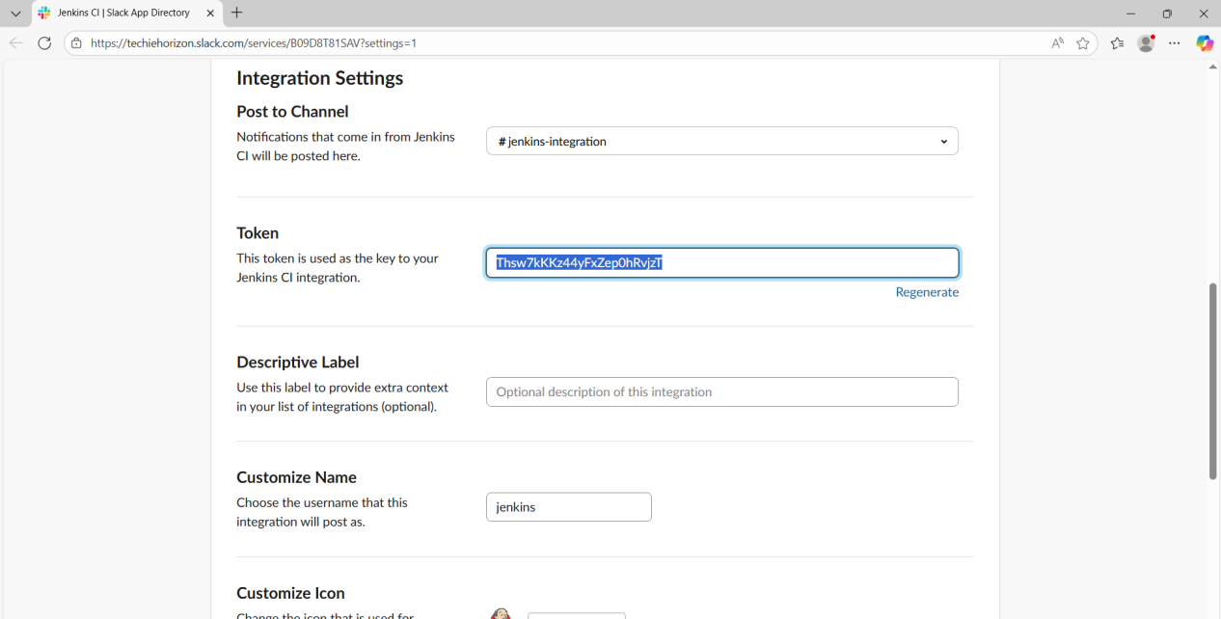

Go to v-profile>configure>enable what we want>SAVE

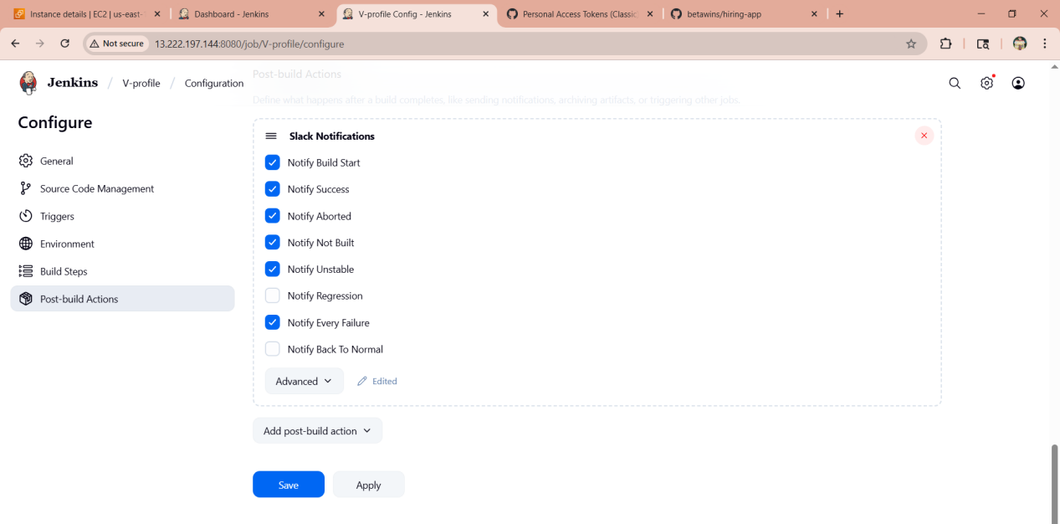

In slack it will show integrations and other executions

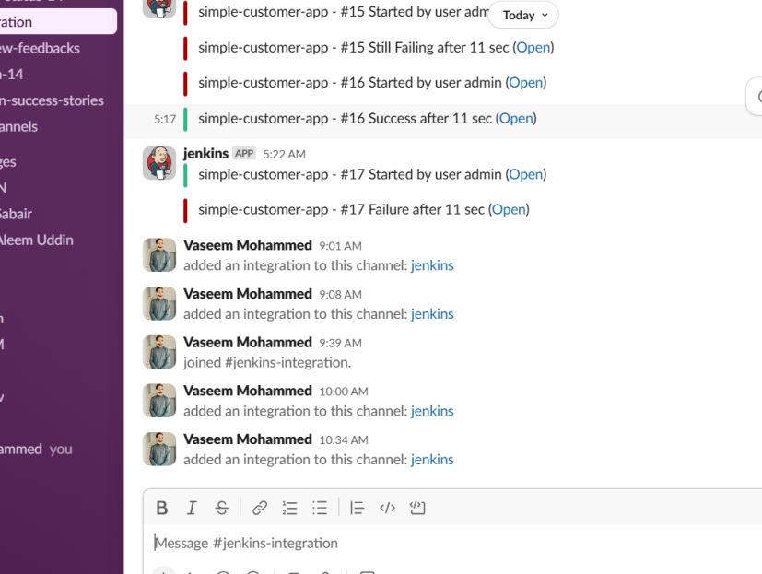

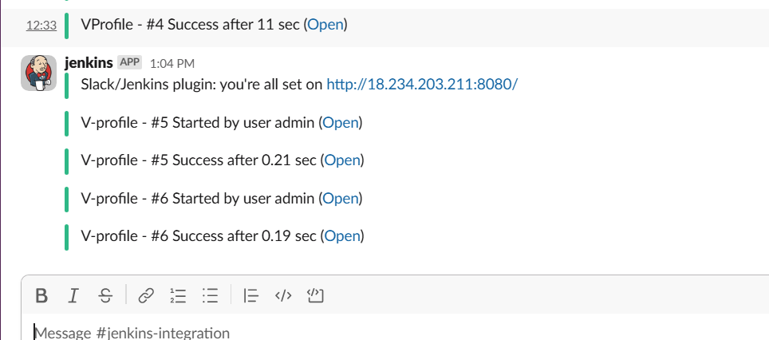

1. **Create one jenkins job using the below code and create three stages.**

Stage:

1: Git clone to download the source code.

2: Sonarqube Integration to check the quality of code stage

3: Slack Integration to send the alerts to slack.

URL: [https://github.com/betawins/hiring-app.git](https://github.com/betawins/hiring-app.git" \t "https://app.slack.com/client/T03TRQ064Q0/_blank)

Installed git

And integrated the hiring app job with sonarwube and jenkins

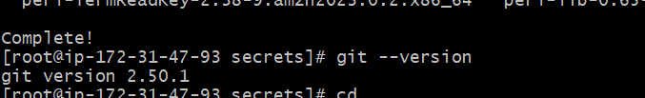

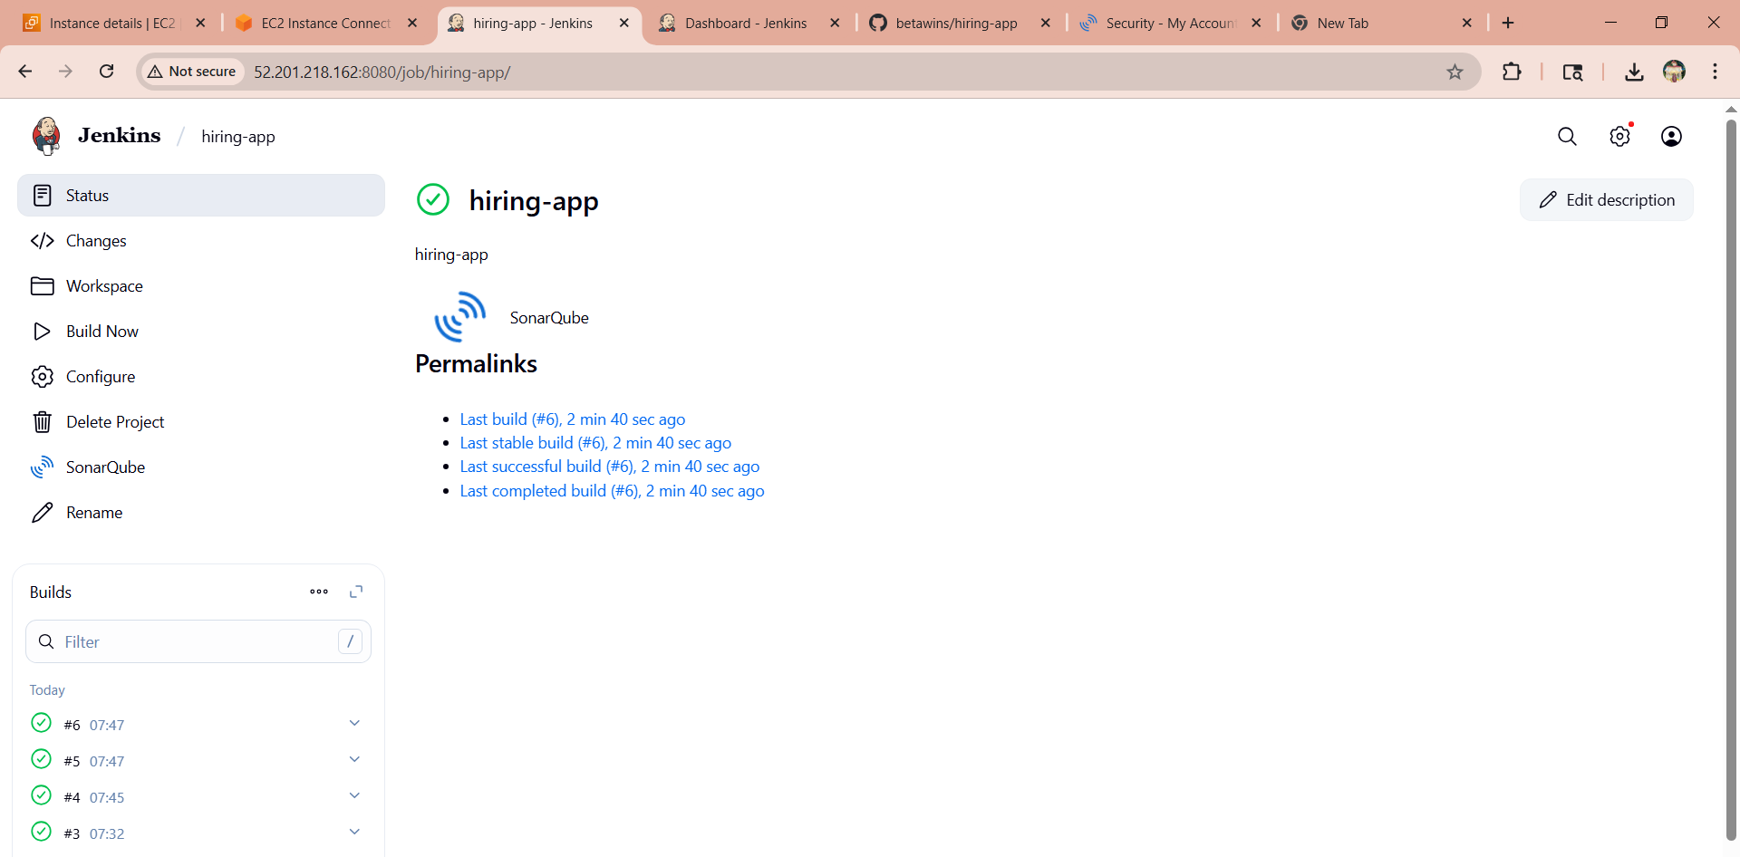

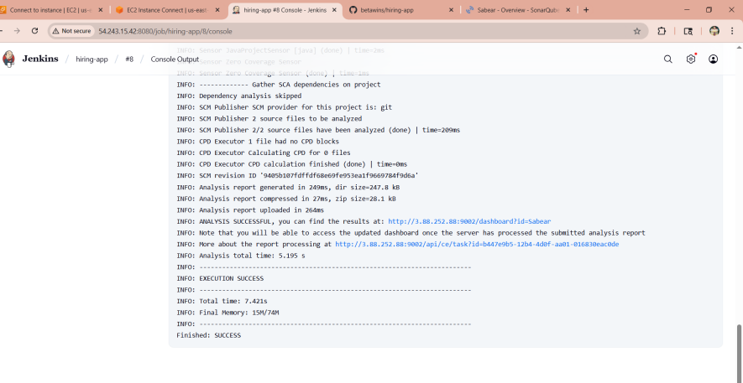

Than we need to go in sonarube and refresh the page will get the output here as PASSED

